- Created table in CK editor

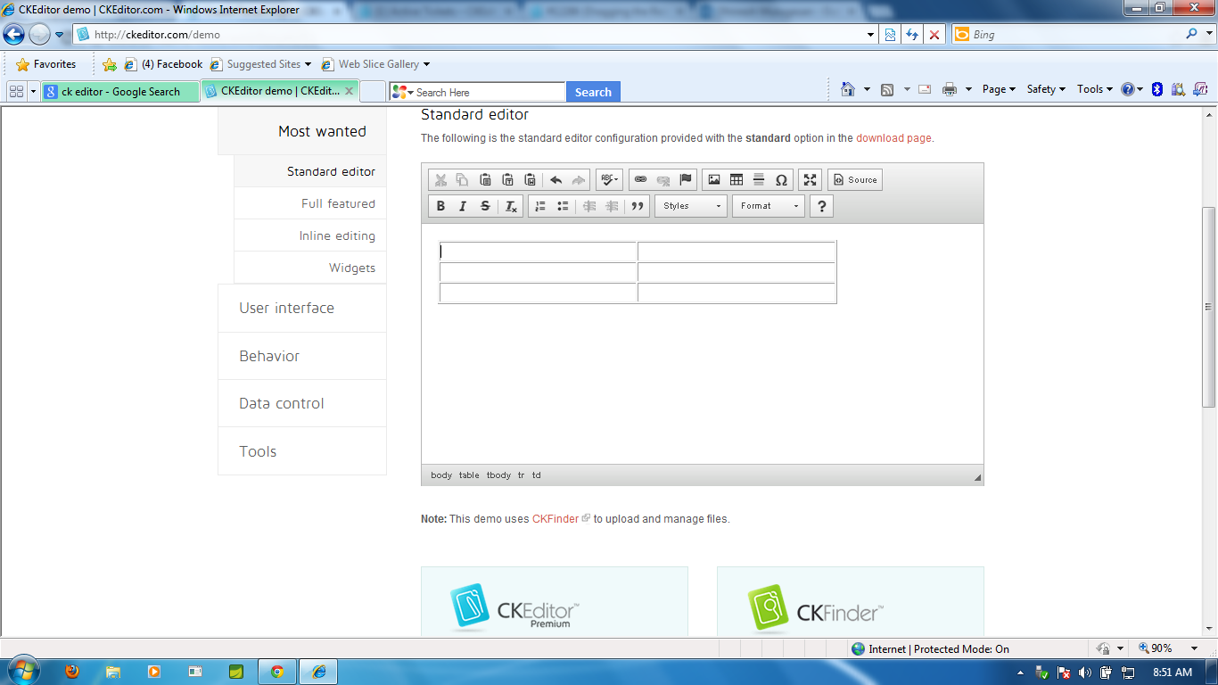

- Make the table resizable by clicking the bottom right corner if table in CK editor
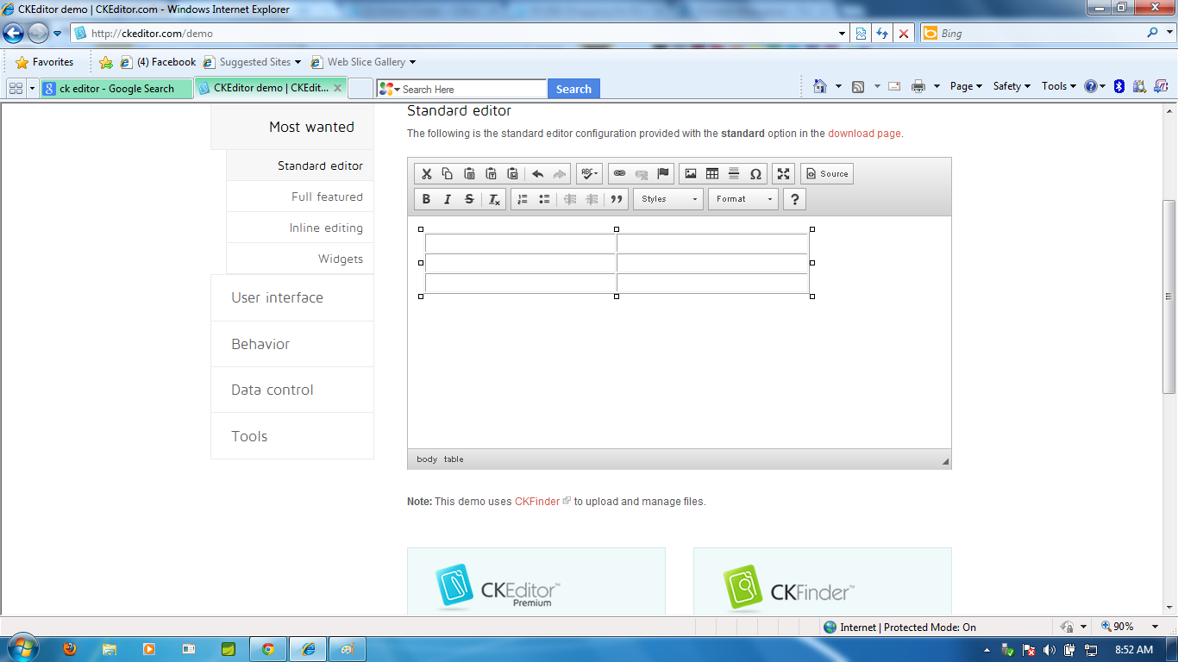

- Drag the resizable corners of the table out of ck-editor
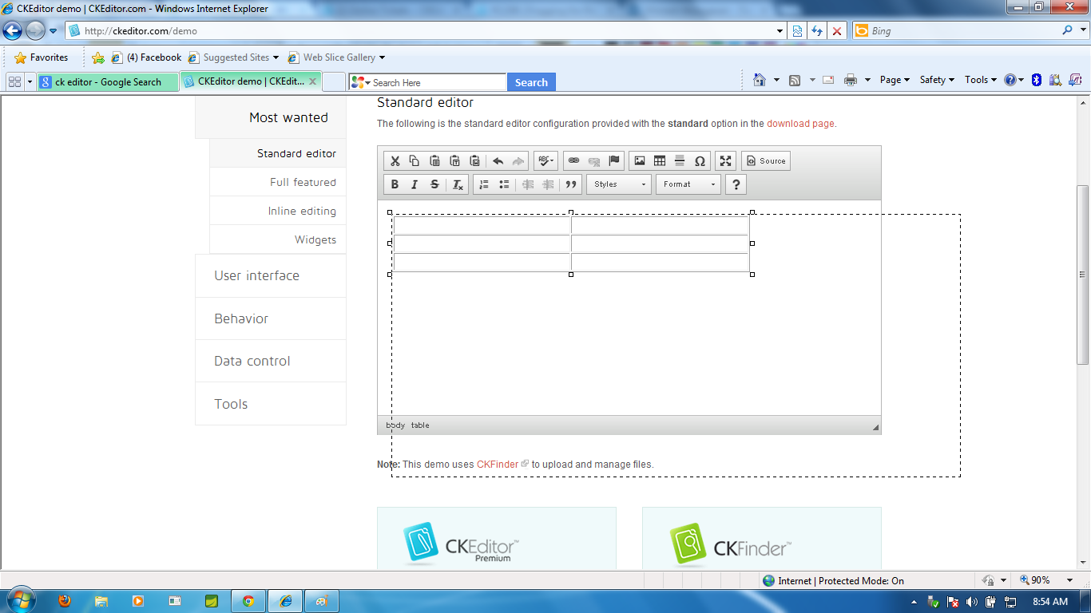

- Now you could find the issue 1: :The dotted resizable corners of the table can be accessed out from the CK editor.
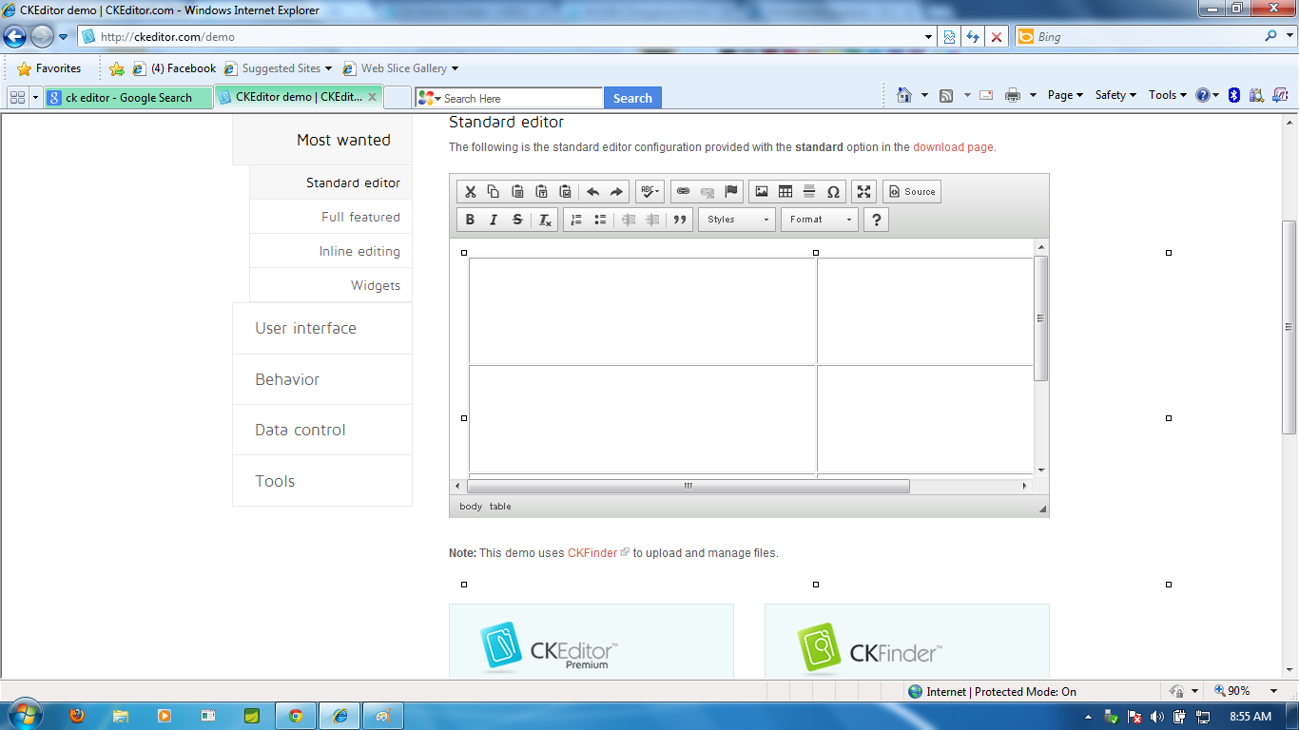
- And issue2: Now when we try to use the scroll of editor, the editor becomes unresponsive.
